**Report Title:**

**TK PAY 2.1 - 31/03/25**

**Department:**

**Payload**

**Report Date:**

**31/03/2025**

**Report Author:**

**Seyed Ali Rashidi - Payload**

**Review/Approval:**

**Pierluca De Felice - Head - Payload**

**Review/Approval Date:**

**30/03/2025**

**Understand how to calculate MTF and SNR for infrared cameras**

# Abstract

This report addresses the challenge of estimating the Signal-to-Noise Ratio (SNR) for infrared cameras to facilitate informed selection. It analyzes methods for predicting SNR performance based on values extracted from camera datasheets and relevant assumptions. The analysis focuses on identifying efficient estimation techniques using readily available specifications, enabling preliminary assessments of camera suitability before detailed evaluation and supporting improved decision-making in infrared camera acquisition for the IGNIS project.

# 1. Camera Features

The Teledyne FLIR BOSON 640 x 512 55mm 8° HFOV - LWIR Radiometric Thermal Camera Core has the following features:

* 640 x 512 - 8° HFOV
* 12 µm pixel pitch VOx microbolometer
* 21 x 21 x 11 mm, (4.9 cm³) camera body
* Weight as low as 7.5 grams
* Low power consumption, starting at 500 mW
* Rugged construction and highest temperature rating -40°C to +80°C
* Consumer Grade <60mK NEDT
* Professional Grade <50mK NEDT
* Industrial Grade <40mK NEDT
* (For more information, see: <https://www.flircameras.com/20640A008.htm?search=flir%20boson%20640&page=3>)

# 2. Camera Specifications

The following table details the specifications of the camera:

(Source: Archive\Payload\Useful Files\Camera datasheet\boson-engineering-datasheet.pdf)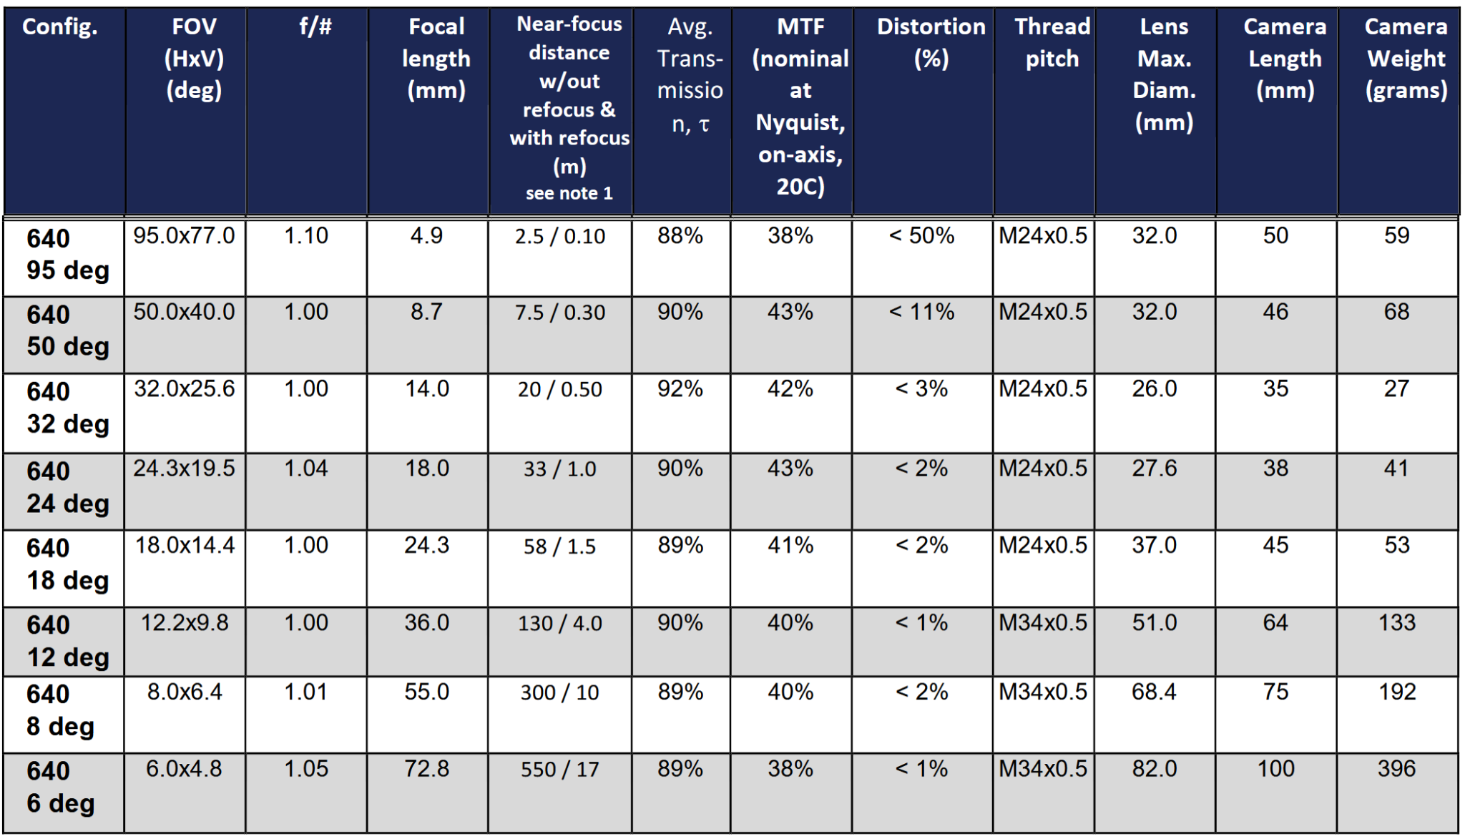

# 3. Analysis

I couldn't find the exact value for SNR of the camera. However, the most important feature available is NEDT (Noise Equivalent Differential Temperature). It represents approximately the minimum temperature difference that a thermal camera can resolve. Therefore, a lower NEDT is better. It is calculated by dividing the temporal noise by the response per degree (responsivity).  
  
The NEDT value is a function of:  
  
1. The focal ratio (f/number)  
2. The integration time  
3. The temperature at which the detection is made

A simple formula can be used to calculate how the NEDT of a thermal imager will be affected by changing the f/number:  
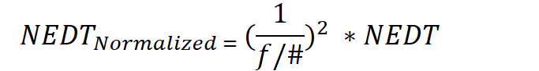  
  
For example, if we have a thermal imager with a NEDT of 50mK and an f/# of 1.6:  
  
NEDT(norm) = 50 * (1 / 1.6)2 = 19mK  
  
This shows that if we change the lens from f/1.6 to f/1.0, the NEDT will decrease from 50mK to 19mK.  
  
We can reverse the formula when we want to increase the f/#:  
  
(f/#)2 * NEDT  
  
We have 3 grades (≤40, ≤50, and ≤60) for NEDT, and I have assumed that they calculated it using an f/1.0 lens.

Now we can calculate the NEDT of the FLIR Boson 640 8-degree lens (see table 10, page 95 of the datasheet):  
(1.01)2 * 40 = 40.804  
(1.01)2 * 50 = 51.005  
(1.01)2 * 60 = 61.206

and the NEDT of the FLIR Boson 640 6-degree lens:

(1.05)2 * 40 = 44.1  
(1.05)2 * 50 = 55.125  
(1.05)2 * 60 = 66.15

We also have 3 other features in table 10 that we need to consider:  
* Avg. Transmission: This is the average percentage of infrared radiation that the lens transmits. The higher, the better.  
  
* MTF (nominal at Nyquist, on-axis, 20C): Nyquist refers to the Nyquist frequency, which is the highest spatial frequency that the sensor can resolve. "On-axis" refers to the center of the image. Of course, the higher, the better.  
  
* Distortion (%): It refers to the degree to which the lens distorts the image, causing straight lines to appear curved. The lower, the better.

# 4. Summary

SNR: I couldn't find the exact value of the SNR for this lens and camera. However, the most important feature we have instead of SNR is NEDT, and the calculated NEDT for the 8-degree lens is:

* (1.01)² * 40 = 40.804
* (1.01)² * 50 = 51.005
* (1.01)² * 60 = 61.206

and the calculated NEDT for the 6-degree lens is:

* (1.05)2 * 40 = 44.1
* (1.05)2 * 50 = 55.125
* (1.05)2 * 60 = 66.15

MTF: As table 10 on page 95 states, the MTF of the 8-degree lens is 40% and the MTF of the 6-degree lens is 38% .

*Seyed Ali Rashidi*

*Payload*

*IGNIS*

*Pierluca De Felice*

*Head*

*IGNIS*